CHAPTER I
THE PROBLEM AND IT’S BACKGROUND

Introduction
Campus safety is a pressing concern in higher education institutions. According to recent studies, thousands of school-related accidents occur annually due to overlooked hazards such as faulty wiring, slippery walkways, and fire risks. These incidents not only endanger students and staff but also disrupt academic operations and strain institutional resources.

At Pampanga State University (Former Don Honorio Ventura State University), where thousands of students, faculty, and personnel occupy shared spaces daily, the risk of both natural and man-made hazards is inevitable. Despite existing safety protocols, many incidents remain underreported or unresolved because traditional reporting methods rely on paper forms, manual submissions, or delayed communication. This outdated process often results in slow response times, limited accountability, and preventable accidents.

With the rapid advancement of technology, digital innovations like Progressive Web Applications (PWAs) present an opportunity to transform risk reporting and hazard management. PWAs are known for their fast loading, cross-platform compatibility, and real-time data synchronization, making them ideal for emergency communication and safety monitoring.

In response, this study proposes RISKWISE—a Progressive Web Application designed for Pampanga State University. The system enables students, faculty, and staff to report hazards using geotagging, incident descriptions, and images. Reports can be submitted even without internet connectivity and are automatically synced when online. Administrators and safety officers access an interactive dashboard to classify risks, assess severity, and initiate corrective action.

By digitizing hazard reporting, RISKWISE aims to promote a safer and more responsive university environment, fostering a culture of accountability and proactive risk management.

Purpose and Description
The purpose of this study is to design, develop, and evaluate RISKWISE, a Progressive Web Application for hazard reporting and risk management at Pampanga State University. The system seeks to replace traditional reporting methods with a centralized digital platform that enhances efficiency, transparency, and collaboration.
RISKWISE features two access levels:
- End-users (students, faculty, staff): Can report incidents with geolocation, photos, and descriptions.
- Administrators (safety officers, compliance team): Can view, classify, and resolve reports via a dashboard, supported by severity scoring and push notifications.
The system complements existing safety protocols by bridging communication gaps, reducing delays, and enabling data-driven decision-making for campus risk management.

Objectives of the study
To design and implement a Progressive Web Application that improves real-time risk assessment and hazard reporting within Pampanga State University.
Specific objectives
- To design a user-friendly reporting interface for submitting incidents with descriptions, geotagging, and photographic evidence.
- To develop an administrator dashboard for monitoring, classifying, and resolving reported hazards.
- To integrate real-time push notifications for safety updates and critical alerts.
- To evaluate the system’s performance and user satisfaction using the ISO/IEC 25010 software quality model, focusing on functionality, usability, reliability, and performance efficiency.
Significance of the study
This study will benefit the following stakeholders:
- University Administration & Safety Officers: Provides a streamlined monitoring tool for faster decision-making and accurate documentation.
- Students, Faculty, and Staff: Empowers users to actively participate in campus safety by reporting risks conveniently.
- Developers and IT Professionals: Serves as a practical case study for applying PWAs to institutional problem-solving.
- Future Researchers: Offers a foundation for exploring AI-driven hazard detection, automated emergency response, or SMS-based safety alerts.
- Academic Community: Demonstrates how digital platforms can be adapted to strengthen safety protocols across educational institutions.

Definition of terms
- Risk Assessment: Identifying, analyzing, and evaluating hazards to determine their impact and necessary response.
- Incident Reporting: Documenting and communicating details of hazards or safety breaches.
- Progressive Web App (PWA): A web application that behaves like a native app, and push notifications.
- Geolocation: The process of determining a user’s or event’s physical location using GPS or similar technology.
- Service Workers: Background scripts that enable PWAs to handle caching, and notifications.
- IndexedDB: A browser-based database for storing large amounts of structured data.
- Push Notification: A real-time alert sent to users even when the app is inactive.
- ISO/IEC 25010: An international standard for evaluating software quality.

Scope and Limitations
This study focuses on the design, development, and evaluation of RISKWISE within Pampanga State University. The system includes:
- Web-based submission of risk reports with geolocation and image attachments
- Administrator dashboard for classifying and responding to incidents
- Real-time functionalities using modern web technologies
- Evaluation using ISO/IEC 25010 standards for quality assurance

Scope and Limitations
- The system will not include native mobile applications (Android/iOS).
- Real-time dashboard updates still require internet connectivity.
- Automated emergency response (e.g., notifying first responders) is beyond the project scope.
- Hazard evaluation relies on predefined models, not AI/ML.
- The system’s effectiveness depends on active user participation and accuracy of reports.
- IoT-based hazard detection hardware is excluded from this version.
Conceptual Framework
The conceptual framework of this study revolves around a three-layered interaction model among users, system, and administrators:
Users (Students, Faculty, Staff): These individuals serve as the primary reporters of risk incidents. They input data such as descriptions, images, and location information via the web interface.
System (RISKWISE PWA): The system collects, processes, and stores risk data either locally or in the cloud. Notifies administrators, and synchronizes data once online.
Administrators (Safety Officers, Compliance Team): Administrators access the dashboard to categorize, validate, and act on submitted reports. They issue alerts, mark reports as resolved, and monitor patterns via analytics.

Figure 1
Conceptual Framework
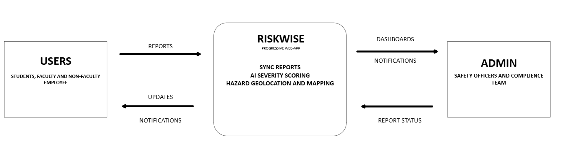
This framework is grounded in responsive communication theory and feedback-based safety management systems, ensuring that reports are not only received but acted upon effectively.

